**PROGRAM 1(a): Write a program to search an element in array linearly .**

**SOURCE CODE**

#include <stdio.h>

void main(){

int n,target,arr[20],flag=0;

printf("Enter the number of elements in the array:");

scanf("%d",&n);

printf("Enter the elements of the array:");

for(int i=0;i<n;i++){

scanf("%d",&arr[i]);}

printf("Enter the element to be searched:");

scanf("%d",&target);

for(int i=0;i<n;i++){

if(target==arr[i]){

flag=1;

printf("Element found at location:%d",i+1);

break;}}

if(flag==0){

printf("Element not found the array:");

}

printf("\n-----------------------------------------------\n");

printf("AKSHAT SRIVASTAVA IT-A\n2300320130025");

}

**OUTPUT**

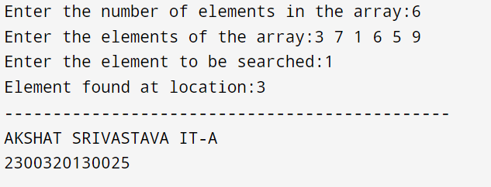

**PROGRAM 1(b): Write a program to perform binary search in array**

**SOURCE CODE**

#include <stdio.h>

int main() {

int n,target,arr[20],flag=0;

printf("Enter the number of elements in the array:");

scanf("%d",&n);

printf("Enter the elements of the array:");

for(int i=0;i<n;i++){

scanf("%d",&arr[i]);}

printf("Enter the element to be searched:");

scanf("%d",&target);

int low = 0;

int high = n - 1;

while (low <= high) {

int mid = (high+low)/2;

if (arr[mid] == target) {

flag=1;

printf("Element is found at location:%d\n",mid+1);

break; // Element found, exit loop

} else if (arr[mid] < target) {

low = mid + 1;

} else {

high = mid - 1;

}

}

if (flag == 0) {

printf("Element Not found in array\n");

}

printf("-----------------------------------------------\n");

printf("AKSHAT SRIVASTAVA IT-A\n2300320130025");

return 0;

}

**OUTPUT**

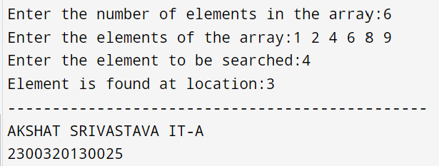

**2(A) :Write a program to implement traversal in an array**

**SOURCE CODE**

#include<stdio.h>

void main(){

int arr[100];

int n;

printf("Enter number of elements:");

scanf("%d",&n);

printf("Enter the elements of array:");

for(int i=0;i<n;i++){

scanf("%d",&arr[i]);

}

printf("Elements of array are:");

for(int i=0;i<n;i++){

printf("%d ",arr[i]);

}

printf("\n--------------------------------------------\n");

printf("AKSHAT SRIVASTAVA\nIT-A\n2300320130025");

}

**OUTPUT**

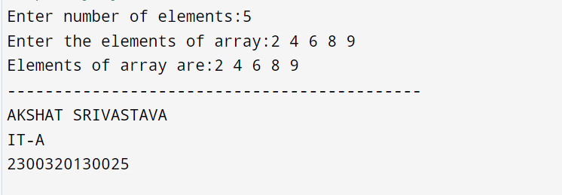

**2(B): Write a program to perform insertion of an element in an array**

**SOURCE CODE**

#include<stdio.h>

void main(){

int arr[100],n,num,pos;

printf("Enter the number of elements in an array:");

scanf("%d",&n);

printf("Enter the elements of an array:");

for (int i = 0; i < n; i++)

{ scanf("%d",&arr[i]); }

printf("Enter the element you want to insert:");

scanf("%d",&num);

printf("Enter the position in which you want to insert:");

scanf("%d",&pos);

for (int i = num-1; i>=pos-1; i--)

{ arr[i+1]=arr[i]; }

arr[pos-1]=num;

n++;

printf("Elements of array are:");

for (int i = 0; i < n; i++)

{ printf("%d ",arr[i]); }

printf("\n--------------------------------------------\n");

printf("AKSHAT SRIVASTAVA\nIT-A\n2300320130025");

}

**OUTPUT**

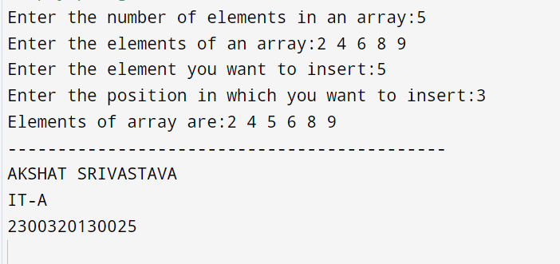

**2(C): Write a program to perform deletion of an element in an array**

**SOURCE CODE**

#include<stdio.h>

void main(){

int arr[100],n,num,pos;

printf("Enter the number of elements in an array:");

scanf("%d",&n);

printf("Enter the elements of an array:");

for (int i = 0; i < n; i++)

{ scanf("%d",&arr[i]);

}

printf("Enter the number you want to delete:");

scanf("%d",&num);

for (int i = 0; i < n; i++)

{ if (arr[i]==num) {

pos=i; } }

for (int i = pos; i < n-1; i++)

{ arr[i]=arr[i+1]; }

n--;

printf("Elements of array are:");

for (int i = 0; i < n; i++)

{ printf("%d ",arr[i]); }

printf("\n--------------------------------------------\n");

printf("AKSHAT SRIVASTAVA\nIT-A\n2300320130025");

}

**OUTPUT**

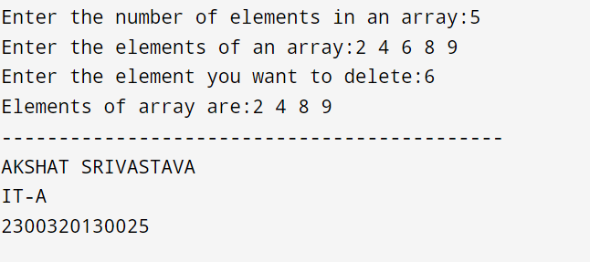

**3)A) Write a program to implement Bubble sort**

**SOURCE CODE**

#include <stdio.h>

int main() {

int arr[20];

int n;

printf("Enter the number of elements in the array:");

scanf("%d",&n);

printf("Enter the elements of array:");

for(int i=0;i<n;i++){

scanf("%d",&arr[i]);}

for (int i = 0; i < n - 1; i++) {

for (int j = 0; j < n - 1; j++) {

if (arr[j] > arr[j + 1]) {

int temp=arr[j];

arr[j]=arr[j+1];

arr[j+1]=temp;}}}

printf("Sorted array: ");

for (int i = 0; i < n; i++) {

printf("%d ", arr[i]);}

printf("\n");

printf("------------------------------------------\n");

printf("AKSHAT SRIVASTAVA\nIT-A\n2300320130025");

return 0;}

**OUTPUT**

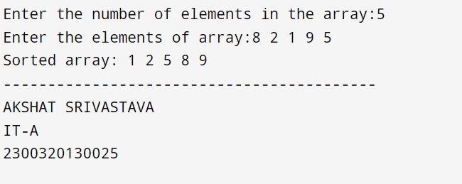

**3)B) Write a program to implement Selection sort**

**SOURCE CODE**

#include <stdio.h>

void selectionSort(int arr[], int n) {

for (int i = 0; i < n - 1; i++) {

int minIndex = i;

for (int j = i + 1; j < n; j++) {

if (arr[j] < arr[minIndex]) {

minIndex = j;}}

// Swap the minimum element with arr[i]

int temp = arr[i];

arr[i] = arr[minIndex];

arr[minIndex] = temp;}}

int main() {

int arr[100],n;

printf("Enter the number of elements: ");

scanf("%d", &n);

printf("Enter the elements:", n);

for (int i = 0; i < n; i++) {

scanf("%d", &arr[i]);}

selectionSort(arr, n);

printf("Sorted array:");

for (int i = 0; i < n; i++) {

printf("%d ", arr[i]);}

printf("\n--------------------------------\n");

printf("AKSHAT SRIVASTAVA\nIT-A\n2300320130025");

return 0;}

**OUTPUT**

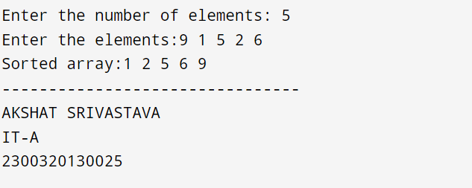

**3)C) Write a program to implement Insertion Sort**

**SOURCE CODE**

#include <stdio.h>

void insertionSort(int arr[], int n) {

for (int i = 1; i < n; i++) {

int key = arr[i];

int j = i - 1;

while (j >= 0 && arr[j] > key) {

arr[j + 1] = arr[j];

j--;}

arr[j + 1] = key;}}

int main() {

int arr[100],n;

printf("Enter the number of elements: ");

scanf("%d", &n);

printf("Enter the elements:", n);

for (int i = 0; i < n; i++) {

scanf("%d", &arr[i]);}

insertionSort(arr, n);

printf("Sorted array:");

for (int i = 0; i < n; i++) {

printf("%d ", arr[i]);}

printf("\n--------------------------------\n");

printf("AKSHAT SRIVASTAVA\nIT-A\n2300320130025");

return 0;}

**OUTPUT**

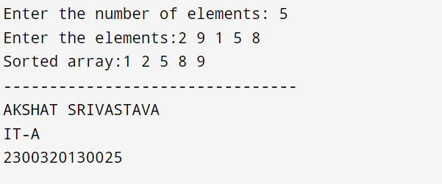

**4)A) Write a program to implement stack using array**

**SOURCE CODE**

#include <stdio.h>

#define MAX 100

int stack[MAX];

int top = 0; // Initialize top to 0

void push() {

int val;

if (top == MAX) {

printf("Stack Overflow\n");

} else {

printf("Enter the value to push: ");

scanf("%d", &val);

stack[top] = val;

top++;

printf("Pushed Element:%d",val);

}

}

void pop() {

if (top == 0) {

printf("Stack Underflow\n");

} else {

top--;

printf("Popped value: %d\n", stack[top]);

}

}

void traverse() {

if (top == 0) {

printf("Stack is empty\n");

} else {

printf("Stack elements are: ");

for (int i = 0; i < top; i++) {

printf("%d ", stack[i]);

}

}

}

int main() {

int choice;

while (1) {

printf("\n------------------------------------------------------------------------------");

printf("\nStack Menu:\n");

printf("1. Push\n");

printf("2. Pop\n");

printf("3. Traverse\n");

printf("4. Exit\n");

printf("Enter your choice: ");

scanf("%d", &choice);

printf("\n------------------------------------------------------------------------------\n");

switch (choice) {

case 1:

push();

break;

case 2:

pop();

break;

case 3:

traverse();

break;

case 4:

return 0; // Exit the program

default:

printf("Invalid choice. Please try again.\n");

}

}

printf(“ABHAY PRATAP SINGH\nIT-A\n2300320130007”);

return 0;

}

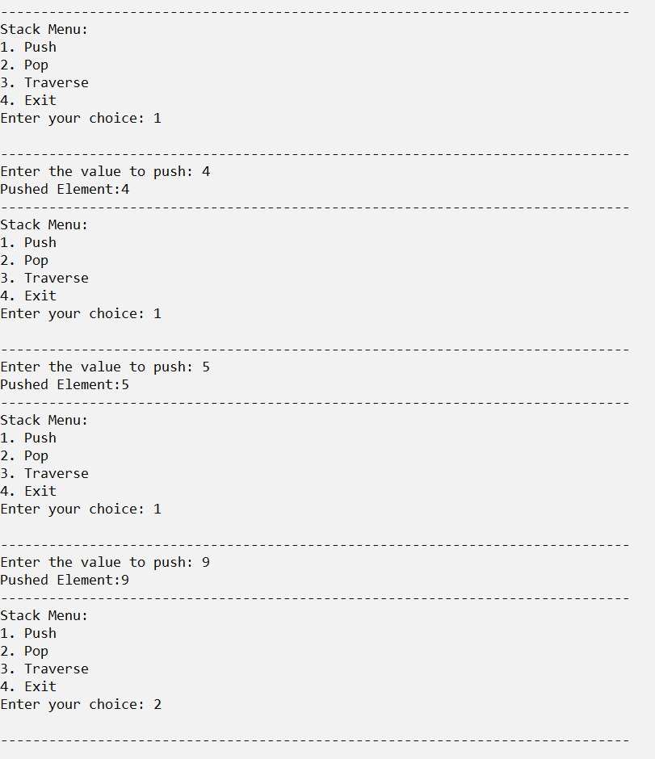**OUTPUT**

